GitHub Actions
Hands-On Lab
Build & Test a Java Application with GitHub Actions


Dr. Serein Al-Ratrout
Assistant Teaching Professor
Computer Science
Software Architecture
Michigan Tech University
Version: V1.0
Date: 1/1/2026
Contents
1) Create the repo (web) 4
2) Create the Java file 4
3) Create the GitHub Actions workflow ( YAML file) 4
4) Breaking down the workflow (step by step) 6
5) Alternative: Start from the Actions tab 8
6) Run and see the output 14

Figure 1: Actions tab 9
Figure 2: New workflow 9
Figure 3: Choose workflow 9
Figure 4: Search actions/checkout 10
Figure 5: Search actions/checkout result 11
Figure 6: Search actions/setup-java 12
Figure 7: Search actions/setup-java result 13

1) Create the repo (web)
1. Go to GitHub → click New repository.
2. Set:
- repository Name: actions-java-demo
- Add README On
- Visibility : Public
3. click Create repository.

2) Create the Java file
- Go to your GitHub repository (or create a new one).
- Click Add file → Create new file.
- In the file name box, type:
Hello.java
- In the editor box, paste this code:
public class Hello {
public static void main(String[] args) {
System.out.println("Hello from GitHub Actions!");
}
}
- Scroll down → click Commit changes

3) Create the GitHub Actions workflow ( YAML file)
- In the same repository, click Add file → Create new file again.
- In the file name box, type:
.github/workflows/java.yml

GitHub will automatically create the .github and workflows folders.
- In the editor, paste one of the following workflows.
Option A- With step names
name: Run Java Program
on:
push:
branches: [ main ]
pull_request:
jobs:
run-java:
runs-on: ubuntu-latest
steps:
- uses: actions/checkout@v4
- name: Set up Java
uses: actions/setup-java@v4
with:
distribution: temurin
java-version: '17'
- name: Compile
run: javac Hello.java
- name: Run
run: java Hello

Option B- Shorter version (no step names)
name: Run Java Program
on:
push:
branches: [ main ]
pull_request:
jobs:
run-java:
runs-on: ubuntu-latest
steps:
- uses: actions/checkout@v4
- uses: actions/setup-java@v4
with:
distribution: temurin
java-version: '17'
- run: javac Hello.java
- run: java Hello

- Scroll down → click Commit changes ✅

4) Breaking down the workflow (step by step)

name: Run Java Program
This is just the name of the workflow.

on:
This tells GitHub when to run the workflow.
on:
push:
branches: [ main ]
pull_request:

- Push:
Optional: Restrict push to specific branches (like main)
Sometimes you want to limit pushes to only the main branch:
branches: [ main ]
If you push (upload) new code to the main branch, GitHub will run this workflow.

- pull_request
If you open a pull request, GitHub will also run this workflow.
jobs:

A workflow can have many jobs. Here we only have one job called run-java.
runs-on: ubuntu-latest
This means GitHub will use a fresh Linux computer (Ubuntu) to run the code.
steps:

Steps are like instructions GitHub follows, one by one.
Step 1 — Checkout your code
- uses: actions/checkout@v4
This downloads your repository into GitHub’s machine so it can access your files.

Step 2 — Set up Java

- name: Set up Java
uses: actions/setup-java@v4
with:
distribution: temurin
java-version: '17'

This installs Java 17 (Temurin distribution) in the GitHub machine. Without this, Java wouldn’t run.

Step 3 — Compile
- name: Compile
run: javac Hello.java

This compiles your Java file: javac Hello.java → turns Hello.java into Hello.class
If your code has errors, GitHub will show them her

Step 4 — Run
- name: Run
run: java Hello
This runs your compiled program. If your Java program prints something like “Hello World”, you will see it in the GitHub Actions logs.

5) Alternative: Start from the Actions tab
Instead of manually creating .github/workflows/java.yml, you can also:

- Go to the Actions tab in your repository.
Figure 1: Actions tab

- Click New workflow

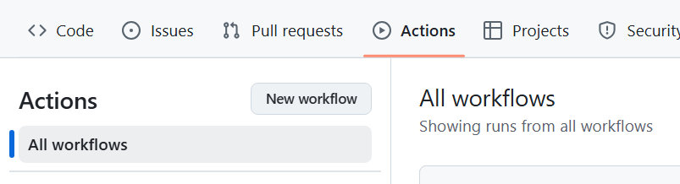
Figure 2: New workflow

- Either:
- Choose a template and edit it, or
- Click “set up a workflow yourself” to start with a blank YAML.

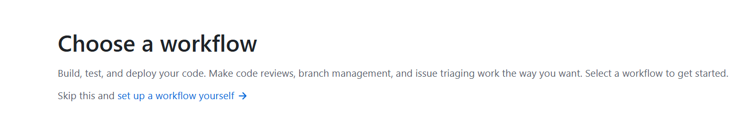
Figure 3: Choose workflow

- Write/paste your workflow and then use the Marketplace panel on the right to search for actions like:
  - actions/checkout
  - actions/setup-java

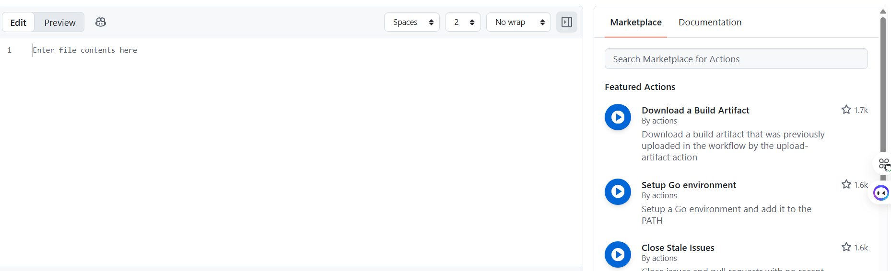
Figure 4: Search actions/checkout

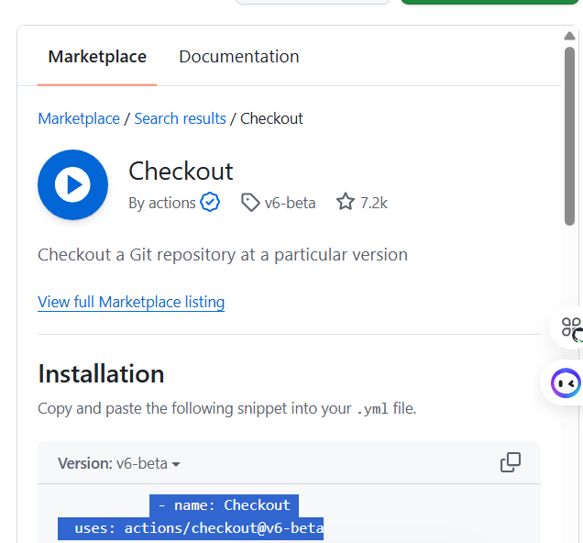
Figure 5: Search actions/checkout result

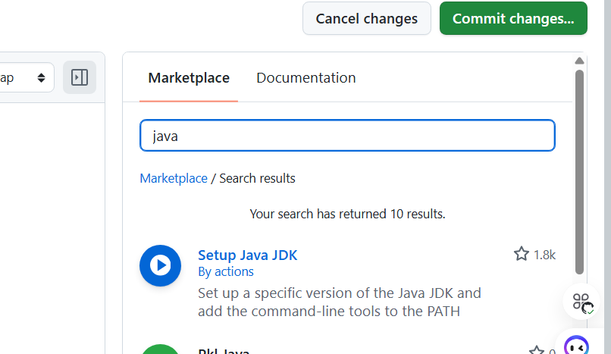
Figure 6: Search actions/setup-java

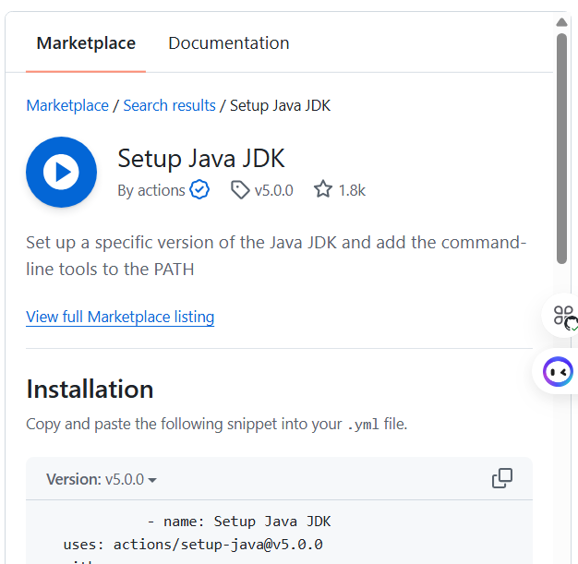
Figure 7: Search actions/setup-java result

5. Commit the workflow file.

6) Run and see the output
- Go to the Actions tab (at the top of your repo).
- You’ll see a workflow called “Run Java Program”.
- Click it → open the latest run → expand the “Run” step.
- You should see:

Hello from GitHub Actions!

